Squares of a Sorted Array
class Solution {
public int[] sortedSquares(int[] nums) {
int n = nums.length;
int[] ans=new int[n];
int left=0, right = n-1;
for(int i=n-1;i>=0;i--){
if(Math.abs(nums[left])>Math.abs(nums[right])) {
ans[i] = nums[left] * nums[left];
left++;
} else{
ans[i] = nums[right]*nums[right];
right--;
}
}
return ans;
}
}
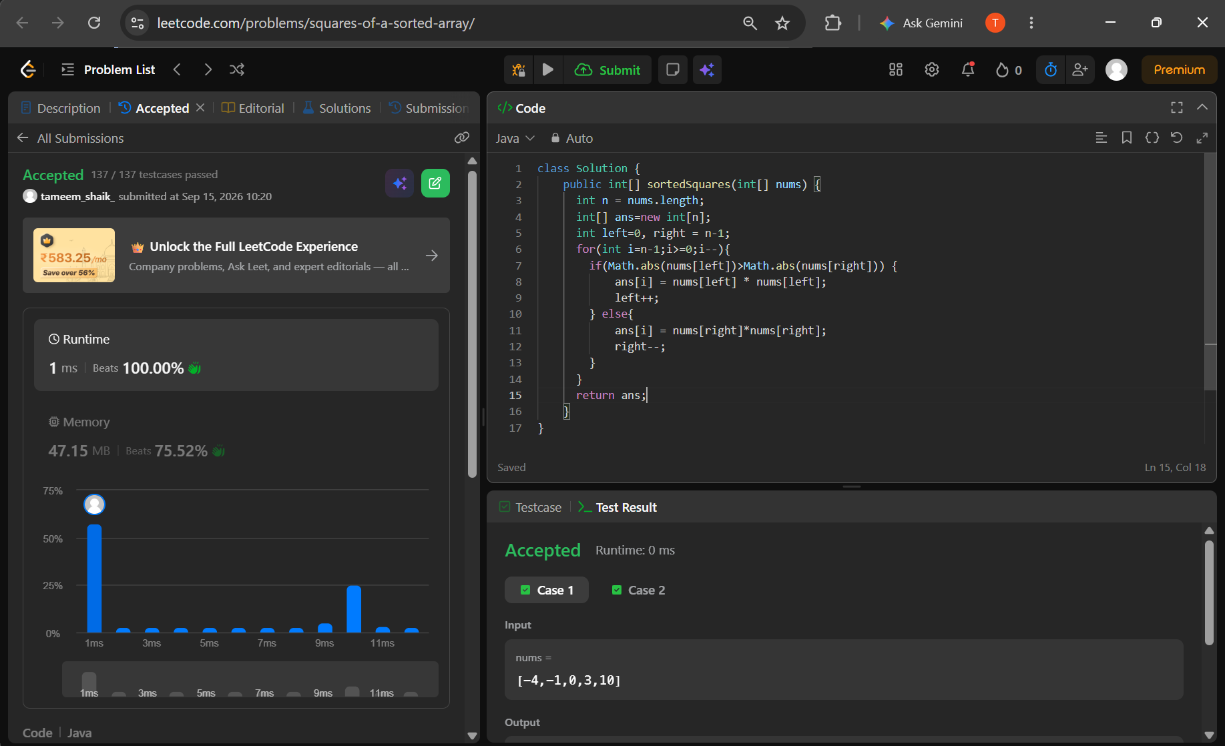

Find Pivot Index
class Solution {
public int pivotIndex(int[] nums) {
int total = 0;
for (int num : nums) {
total += num;
}
int leftSum = 0;
for (int i = 0; i < nums.length; i++) {
int rightSum = total - leftSum - nums[i];
if (leftSum == rightSum) {
return i;
}
leftSum += nums[i];
}
return -1;
}
}
